AnnaMariaHeberle-b1786-d1873OrefieldLehighPA

Birth: | May 22, 1786
Death: | Feb. 20, 1873
Wife of Adam Heberle. On same plot with Adam Heberle and Edwin and Maria Heberly. Next to plot for Solomon and Clarissa Heberly and also Heister.
Burial:
Jordan Lutheran Cemetery
Orefield
Lehigh County
Pennsylvania, USA
Plot: Section E, Lot 38
Created by: Sandra Clauser Culp
Record added: Jun 08, 2008
Find A Grave Memorial# 27406775

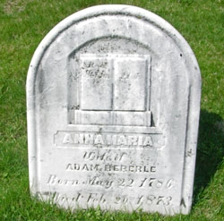
Added by: Sandra Cl

