Well known Heberle
Ronald Leslie Heberle
Messenger boy 1926-30. Fished with his father 1930-32 and worked in Kalgoorlie in 1932. Fisherman on the south coast of WA 1932-60, apart from the war years. Lived in Katanning 1946-58 and then Albany. Full time fisherman until 1968 and then fished salmon seasons (February-April) at Doubtful Island Bay and had other jobs in between seasons, including vegetable cannery field operations, and carrier (tip truck). Has 850+ native orchid photos on the Internet, has published 16+ papers on native orchids 1981-2004 and has 2 orchids named after him, Caladenia heberleana and Diuris heberlei. Another orchid, Prasophyllum paulineii, is named after his wife, Mrs Pauline Graham Heberle. Has attended conferences on native orchids.
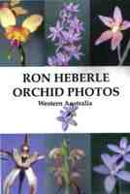 | 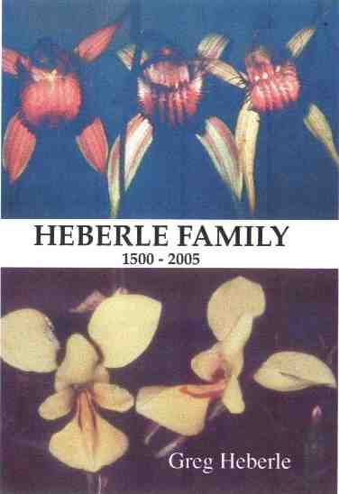
Ron Heberle Orchid Photos book (2006) | Heberle Family 1500-2005 book (2005) top right is Caladenia heberleana, bottom is Diuris heberlei

Ron L Heberle (1981)"A further look at Pterostylis barbata Lindley and P plumosa Cady" Orchadian 7 (2) p36-37.
Ron Heberle (1982) “ "Caladenia in Western Australia and natural hybridisation" Orchadian 7 (4) p78-83.
Ron Heberle (1984) 'Thelymitra macmillanii in Western Australia" J. Nat. Orch. Soc. S. Aust. October 1984.
Ron L Heberle (1986)"Caladenia bryceana R S Rogers; the dwarf spider orchid" In Australian Orchid Review 51 (1) p46-47.
Ron L Heberle (1986) "A putative hybrid from Albany, WesternAustralia, Thelymitra Fuscolutea var. fuscolutea R.Br. x T. nuda R.Br." Orchadian 8 (7) p149-153.
Ron Heberle (c1986)"History of orchid collecting in South Western Australia 1791-1971" chapter 4 p31-54 in Kingsley W Dixon & Bevan Buirchell eds "Orchids of Western Australia Cultivation and natural history".
Ron L Heberle (1988)"The Country Fish Supply" in Editor: Ross Anderson "Katanning - A century of stories" Katanning Shire Council 1988.
Ron L Heberle (1991)"Thelymitra, the Sun Orchids of South Western Australia - The genus" Proc 12th Australian Orchid Conference, Perth 1991 OSWA, p1-6
Ron L Heberle (1992)" "Naming and identification of Western Australian Caladenias" W.A. Nat. Orc. Study and Conservation Group, June 1992, p4-5.
Ron Heberle (1992)“Western Australian terrestrials – Thelymitra’ Australian Orchid Review 57 (2) p 13-14.
Ron L Heberle (1994)"Caladenia species and their putative hybrids" W.A. Nat. Orc. Study and Conservation Group, June 1994, p2-8.
Ron L. Heberle (1995)"Taxonomic Treatment of Caladenia in South-Western Australia - Appraisal, 1995" Orchadian 11 (10) December 1995, p479-486.
Ron L Heberle (1996)"Caladenia in Western Australia and natural hybridisation" Proc Third Australasian Native Orchid Conference Sept 1996 Flinders Univ Adeaide p47-53 Native Orchid Soc SA.
Ron L Heberle (1999)"Thelymitra variegata - The Queen of Sheba" Orchadian 13 (2) p73-77.
Ron L Heberle (2000)"Thelymitra spiralis (Lindl) F. Muell - Curly Locks" Orchadian 13 (6) p252-253.
Ron L Heberle (2003)"Caladenia filamentosa ? in the south west of Western Australia" Orchadian 14 (4) p166-169.
Ron L Heberle (2004)"Rhizanthella gardneri - The underground orchid" The Orchadian 14 (6) p 272-273.
Born/Geboren/Né/Nascido: 24.12.1913 Perth, died 5.2.2004 Perth, West Australia.
Parents/Eltern/Parents/Pais: Leslie and Eva Furniss Heberle. Clausthal-Zellerfeld branch.
Married/Verheirat/Epousé/Casado: Pauline Emily Graham.
Children/Kinder/Enfants/Crianças: Gregory William, Merilyn Eva, Ronald Graham, Grant Anthony, Patricia Robin (Tricia), Milanna Marie.

