Well known Heberle
Heberle Stables, 751 Browncroft Boulevard, Irondequoit, Rochester, New York, USA
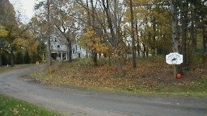

Heberle Stables is an equestrian center at 751 Browncroft Boulevard in Irondequoit, Rochester, New York, USA.
The Heberle family has been serving the equestrian needs of Rochester since 1926. Located adjacent to scenic Ellison Park, Heberle stables is a full service lesson and boarding facility. Currently managed by William R Heberle and his wife Heather, previously managed by his father Oscar Joseph and grandfather Henry Alfred Heberle (Laudenbach branch).
Facilities
- 140 x 140 Geodesic Dome Indoor Riding Ring
- Heated Rest Room, Tack & Viewing Room
- Two fully equipped wash stalls
- 40 box stalls (12’x12’)
- A.R.I.C.P Certified Instructors
- Four "Turn Out" areas
- Trails through Ellison park
- Evening coach rides
- Shipping available

