Well known Heberle
Heberle Ford and Mercury, Forsyth, Montana, USA
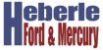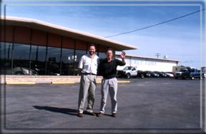

Adeline and Karl Heberle moved to Forsyth in 1959, owning and operating Tepee Motors, which later became Heberle Ford. Their 6 sons took over the business, to build it into the largest Ford and Mercury dealership in Eastern Montana. The brothers, Erwin Leo, Raymond, Clarence Howard, Karl Reinhardt, Elmer Eldon and Frederick Henry of Alpirsbach branch, have since retired. In 1973, Heberle Ford & Mercury moved to its current location, in the east side of Forsyth. There, owners Raymond Todd (son of Raymond and Viola Leming Heberle) and Brent Eldon Heberle (son of Elmer Eldon and Mary Buyse Heberle) sell cars.

