Well known Heberle
Heberle Elementary School, 2015 Freeman Avenue, Cincinnati, Ohio, USA
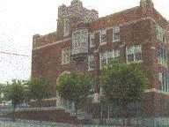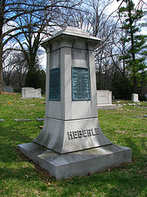

The Heberle Elementary School was located at 2015 Freeman Avenue. The school was built in 1929. About 950 students attended this school in 1998, c70% African-American and 27% white. This building contains many decorative features, including a tiled fountain dedicated to Joseph A Heberle. The school was relocated in c2007, due to safety concerns. and is now at. Students at that time were about 400, c96% African-American. The school has since been located at 1035 Mound Street and 1030 Cutter Street, Cincinnati. Joseph Heberle was an early school advocate, winning support for free textbooks in the public school system. He was a teamster and trade unionist. He founded the Teamsters union in Cincinnati. There is a monument to Joseph Heberle in Cincinnati.
Born/Geboren/Né/Nascido: 1862 Stuttgart, Germany.
Parents/Eltern/Parents/Pais: unknown.
Not married ?

