Well known Heberle
Gastehaus Heberle, Dr Zimmermann str 14, Immenstaad
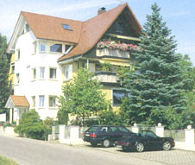
Guest house in Immenstaad, Baden Wurttemberg, Germany. Immenstaad is 20km SE of Uberlingen, on Lake Bodensee. The guesthouse has been operating since 1938. Current owners are Walter and Christine Heberle. The guest house has 24 beds.
There have been 2 other Heberle guesthouses in Immenstaad. Haus Heberle (3 beds), at Seestrasse West 14, Immenstaad, owned by Rainer and Resi Heberle.
Haus Rosengarten at Schulstrasse 4, Immenstaad, owned by Karl and Petra Heberle.

