Viola “Vi” M. Heberle, 82, of Forsyth

March 11, 1930 – January 30, 2013
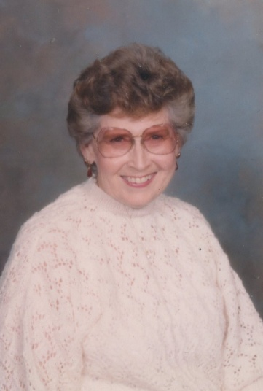
Viola Heberle passed away January 30, 2013 in Billings, MT. Wife, mother, grandmother, great-grandmother, sister and friend. She will be greatly missed by many.
Viola was born March 11, 1930 to Preston and Mary Leming in Battlecreek, MI. She grew up in Hysham, MT and graduated from Hysham High School in 1949. She met the love of her life Raymond Heberle when she was 16 years old at a dance in Sanders, MT. They married on August 11, 1951 and lived in Custer MT. They had two children RaDonna and Todd.
The family moved to Forsyth MT in 1967. Viola lived doing what she loved the most; being a wife, mother and later, grandmother. She loved Christmas and each generation will carry memories of those special occasions we shared with her.
Viola was preceded in death by her husband Ray, parents Preston and Mary Leming, and a brother Joe Leming, .
She is survived by children RaDonna McComb of Billings, MT, Todd (Tracy) Heberle of Forsyth, MT. Four grandchildren Kris (Cheryl) Crosby, and their children Ethan and Elias of Waseca, MN, Jessica (Clay) Blackwell and their children Hailey, Hunter, Heather, Hannah, and Hudson of Forsyth, MT, Michael McComb of Billings, MT, Adey (Anthony) DeSocio and their children Brooklynn and Benton of Billings, MT, a sister MaryDell (Gary) Baker of Sula, MT, Charles Leming of Billings, MT, Glen (Rexine) Leming of Springfield, MO, and David (Linda) Leming of Salem, OR.
Services will be held at the Federated Church in Forsyth, MT on February 2, 2013

