In Memory of

Margaret E. Heberle
March 31, 1914 - July 26, 2012
Obituary

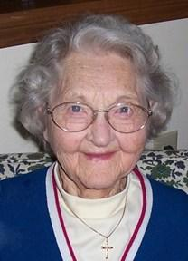
HEBERLE, MARGARET E., age 98, passed away on Thursday, July 26, 2012 at The Hospice of Dayton. She was preceded in death by her parents, Jacob and Balbina Heberle, brothers Walter and James Heberle, and sisters Lauretta Marks, Helen Freeberg, and Rosemary Gottschlich. Surviving her are nine nieces and nephews, and many great nieces and nephews. Margaret was with Ohio Bell Telephone and then Bell Labs for 45 years. A self-made person, she entered the organization as a telephone operator following high school and became a clerk for many years while going to night school. She persuaded the company to let her take its courses in radio, electronics, computers, and mathematics, took the books home and studied at night on her own. No woman had ever taken these courses, and she passed them all, eventually teaching the courses and leading an engineering group before being offered a job at Bell Labs in 1973 where she supervised a program adapting engineering to computer operating systems at the advent of computers and the transistor. She eventually earned two associate degrees, one in science and one in mathematics before retiring in 1977. Margaret was a member of the Ohio Bell Choir, St. Marys Church Choir, the Church of the Incarnation Choir and the Cameo Chorale. Following her retirement, she volunteered as a bookkeeper at the Nearly New Shop of the Little Exchange for 25 years and was a tax counselor for the elderly at Bethany Village until just a couple of years before her death. The family will receive friends from 5:00 to 7:00 p.m. on Tuesday, July 31, 2012 at the TOBIAS FUNERAL HOME – FAR HILLS CHAPEL, 5471 Far Hills Ave. at Rahn Rd., Dayton, Ohio 45429. Mass of Christian Burial 10:30 a.m. Wednesday, August 1, 2012 at the Church of the Incarnation, 7415 Far Hills Ave., Centerville, Ohio 45459. Interment Calvary Cemetery.

