AnnaSchausHeberle-b1882-d1962HendersonMN
Birth: | Oct. 10, 1882
Death: | Jan. 31, 1962
Anna Schaus Heberle was born on Oct 10, 1881 in Henderson, Sibley Co., Minnesota. Her parents were Mathias Schaus of Trier, Germany and Catherine Betz of Granby, Nocollet, MN. Anna had five sisters and 4 brothers. She married Alois Heberle on Oct 14, 1913. She had 4 children: Alois G, Robert J, Clementine Rose and Lucille Catherine. Anna passed away on January 31, 1962. Services were held on Sat. Feb 3, 1962 and was interred at St. Joseph's Cemetery
Burial:
Saint Josephs Catholic Cemetery
Henderson
Sibley County
Minnesota, USA
Plot: block 1, Lot 10
Created by: Roberta Heberle
Record added: Jul 24, 2008
Find A Grave Memorial# 28506657

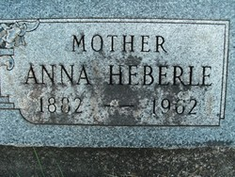
Added by: Ladygraver
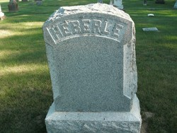
Added by: Ladygraver

