Dorothea L. Heberle
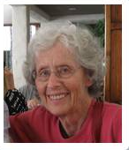
November 15, 1930 - January 27, 2017
Born in Chicago. IL
Resided in Williamsville, NY

HEBERLE, Dorothea "Thea" (nee Lindsay)
January 27, 2017, at age 86, beloved wife of Juergen Heberle; devoted mother of Thomas (Ajin) Heberle and Laura (John) Heberle; cherished grandmother of Lindsay and Matthew Lorincz; dear sister of Katie Lindsay. Thea was a long time teacher in the Amherst School District and Erie BOCES I.

