ChristianHeberle-b1829-d1896-VeronaNY
  Birth: | 1829
  Death: | Sep. 2, 1896  Verona  Oneida County  New York, USA
  Died Sept 2, 1896
  CHRIS HEBERLE
  Word was received here Wednesday of the death of Chris Heberle, of Verona Mills, who died suddenly at Henry Joslin's near Verona village this morning. The deceased was well known around Verona. His wife survives, also two sons. Mr. Heberle was in Rome yesterday and complained nor feeling well.
  Coroner Nock went to Verona yesterday and after investigating the cause of Mr. Heberle's death decided that an inquest was unnecessary. The cause of death was apoplexy.
  -------------------
  The funeral of Christian Heberle was held on Friday afternoon at the German Luther Church. Rev. Oscar Krauch preached the sermon in German. Mr. Heberle was a native of Germany, was 67 years old and came to this country in 1848. He was a member of the German Lutheran Church, a kind neighbor and a true friend. He will be greatly missed by a large circle of friends. Besides his wife, he leaves two sons, Edward of Rochester, and Arthur of this place.
  Burial:
  Saint Peters Lutheran Cemetery
  Churchville
  Oneida County
  New York, USA
  Plot: section 2
  Created by: Bea Lastowicka
  Record added: Jun 18, 2006
  Find A Grave Memorial# 14638414
  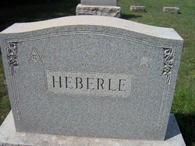
  Added by: Bea Lastowicka
  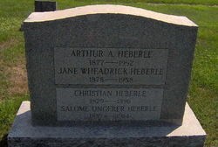
  Added by: Bea Lastowicka
  