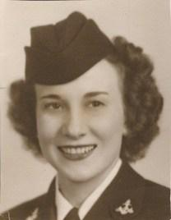  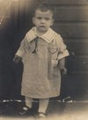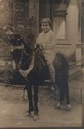 |  | In Memory of  Berneta Carolyn (Heberle) Crumley  December 12, 1920 - March 5, 2012  Obituary  Berneta Carolyn "Nana" Crumley, 91, Alexandria, VA passed on Monday, March 5th, 2012 at Alexandria INOVA Hospital. Nana was born in Pittsburgh, PA on December 12th, 1920 to Bernhardt and Magdalena Heberle.  During World War II, Nana served as a Navy Hospital Corpsman. While stationed in San Diego, California, she met and married her husband, Senior Chief Hospital Corpsman Doyle Jerome Crumley. During their 49 year marriage, Nana accompanied Doyle on various Naval assignments to California, Maryland, North Carolina, Virginia, and Hawaii. At those locations, Nana served as a secretary at various Navy and Army installations. In 1968, Nana and Doyle retired to Florida, where they lived until Doyle's passing in 1994.  Nana is survived by her companion, William Wise; daughter, Diane and husband, Alton McGill of Alexandria, VA; son, Glenn and wife, Patricia Crumley of McLean, VA; granddaughter, Shelley and husband, Joseph Kuhlmann of Alexandria, VA; granddaughter, Heather and husband, Brian Rosenberger of Burke, VA; and five great-grandchildren - Derek, Mia, Drew, Sean, and Aubrey.  In addition to her husband, Doyle, she was predeceased by her brothers, Clarence and Russell.  Nana's most loved and treasured joys were her granddaughters, Shelley and Heather. A wonderful mother, mother-in-law, grandmother and great-grandmother, she will be missed by all.  Graveside service with Military Honors will be held at Arlington National Cemetery on Thursday, April 12th at 10:00 am.

